**BEHAVIOURAL DIAGRAMS**

*USE CASE DIAGRAM*

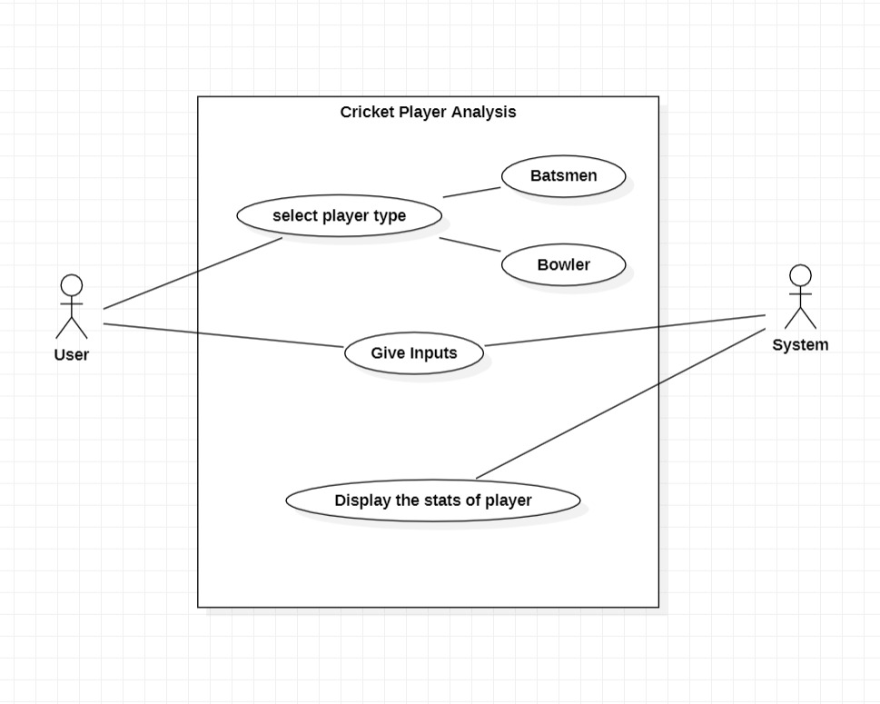

* A use case diagram can summarise the details of your system's users (also known as actors) and their interactions with the system in the Unified Modeling Language (UML). You'll need a collection of specialised symbols and connectors to construct one. A good use case diagram can assist your team in discussing and representing:
* Interactions between your system or application and people, organisations, or external systems
* Goals that your system or application assists those entities (sometimes referred to as actors) in achieving
* Your system's capabilities

*SEQUENCE DIAGRAM*

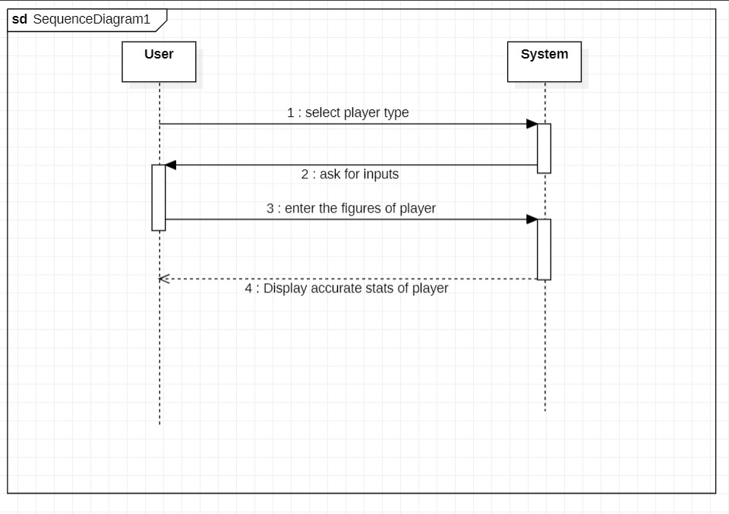

* A sequence diagram is a sort of interaction diagram that shows how a group of items interacts and in what order. Software engineers and business experts use these diagrams to understand the requirements for a new system or to describe an existing process. Event diagrams and event scenarios are other names for sequence diagrams.